 | NCDOT Guidance for Land Use Scenario Assessment

INTRODUCTION

Purpose and Background
The purpose of the LUSA Guidance Document is to define the procedure for conducting a Land Use Scenario Assessment (LUSA) for a proposed NCDOT roadway project and to assist with the completion of the LUSA Report Template, available as a separate document. The resultant LUSA Report, which is to be completed by Community Studies (CS) Staff and/or Project Consultants, is intended to provide an update to the ICE Report, develop land use scenarios, and assess the scenarios for indirect land use effects based on a review of population and economic trends and forecasts, notable human and natural environmental features, water and sewer availability, available land, market for development, local growth management regulations, and land use plans. This report should specifically address resource agency and permitting requirements for reviewing future land use effects.
The LUSA Report provides the Project Manager, Project Delivery Team, and NCDOT Project Development Unit with the information needed to avoid and minimize potential impacts and/or adequately prepare for the permitting process and any required mitigation and permitting issues that may arise in the future. If the LUSA findings indicate high levels of concern for potential for indirect land use impacts, NCDOT Natural Environment Section (NES) can initiate an Indirect and Cumulative Impacts (ICI) Water Quality assessment.
The LUSA Report will have various audiences—internal NCDOT decision-makers and regulatory and environmental resource agencies such as the US Army Corps of Engineers and the NC Division of Water Resources, as well as additional agencies where appropriate (for Merger projects, all Merger Team members will be included). The distribution of the LUSA Report should conform to the “Distribution lists for Community Studies reports” memo sent from CS to Project Managers in January 2014. The memo identifies individuals to whom final versions of CS reports should be distributed.

Initiation of Procedures
CS makes a determination that a LUSA is warranted based on the matrix results from the ICE Report and in consultation with the Project Manager. The LUSA procedures are initiated through the Environmental Tracking and Coordination System (ETRACS). Initiation of the report is based on several factors: CS timeline memo, project management decisions, project type, and funding.

FORMAT AND USE OF GUIDANCE
This LUSA Guidance Document is intended to assist the planner(s) with completing a LUSA for a proposed NCDOT project. It provides step-by-step directions for: conducting an interview, updating the information contained in the ICE Report, completing the LUSA matrices, and preparing the LUSA Report Template. These documents are separate from the guidance, and available from the CS Group. This guidance is organized into six parts:
- Part A. Project Initiation and Set-Up
- Part B. Verify and Update Information from ICE Report
- Part C. Interviews and Field Visit
- Part D. Land Use Development Scenarios
- Part E. Land Use Development Scenario Assessment
- Part F. Indirect and Cumulative Effects Assessment

Use of Guidance
The recommended approach for users of this guidance is to read through the document in its entirety to familiarize themselves with the LUSA process. The procedural guidance outlined below includes steps with corresponding icons depicting the action(s) performed. These include:
 | Step involves project initiation and coordination with the CS Group
 | Step involves developing Project Mapping. |  | Step involves conducting a Field Visit of the FLUSA, which may be done concurrently with interviews.
 | Step involves submitting the proposed FLUSA to the CS Group for approval before proceeding. |  | Step involves rating categories in one of the four matrices.
 | Step involves conducting interviews with local planners and stakeholders using the LUSA Comprehensive Interview Form. |  | Step involves completing sections of the LUSA Report Template.

Scheduling and Time Constraints
The LUSA occurs after the ICE Report has been completed (after Concurrence Point (CP) 2 within the Merger Process). In some cases, a Community Impact Assessment may be completed after the ICE Report, but before the LUSA. The LUSA informs the selection of the Least Environmentally Damaging Practicable Alternative (LEDPA). If the LUSA findings indicate high levels of concern for potential for indirect land use effects, NCDOT Natural Environment Section (NES) can initiate an Indirect and Cumulative Impacts (ICI) Water Quality assessment following the LUSA.
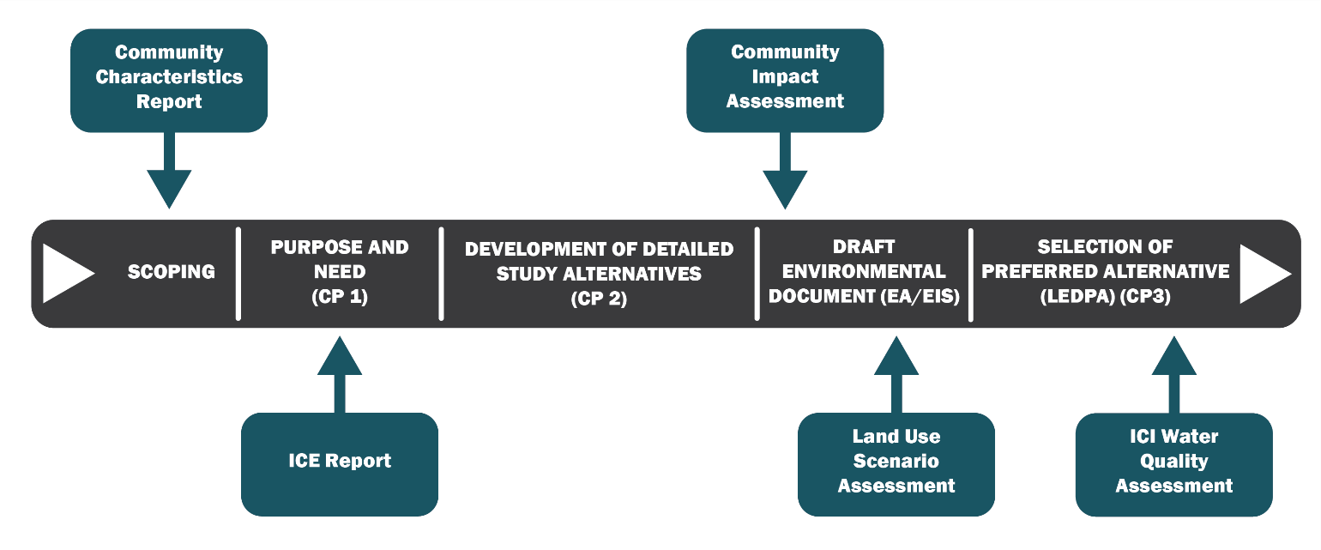

Responsibility
The CS Group is responsible for initiation, completion, and review of the LUSA.

Policy, Regulatory, and Legal Requirements
Additional information about the National Environmental Policy Act (NEPA) can be found at the following website addresses:

Federal Highway Administration (FHWA)
https://www.environment.fhwa.dot.gov/projdev/pd2implement.asp

Additional information about the State Environmental Policy Act (SEPA) can be found at the following website address: http://www.ncleg.net/EnactedLegislation/Statutes/HTML/ByChapter/Chapter_113A.html

PART  A | Project Initiation and Set-Up
1 | Coordinate with NCDOT CS Group
A |  | Review project information, define the regional context of the project, and review online resources for trends, notable features, and initiatives in the area. Get previous studies from NCDOT (e.g. CCR, ICE, CIA).
B |  | Obtain the accompanying ICE and LUSA documents from Connect NCDOT or from CS Staff:  - ICE Guidance Document  - LUSA Report Template  - LUSA Comprehensive Interview Form  - Indirect Effects Matrix  - Land Use Scenario Assessment Matrix  - Cumulative Effects Matrix – Human Environment  - Cumulative Effects Matrix – Natural Environment  This LUSA guidance is intended to be flexible to meet the individual needs of each project. Consult with the CS Group if the project warrants the steps to be completed in an order different from the one presented in this document.

2 | Determine the Future Land Use Study Area
A |  | Verify, and update if needed, the table of transportation and land use plans contained in the ICE Report. Determine if the FLUSA used in the ICE needs to be revised. If it needs to be revised, collect the GIS data needed for revising the FLUSA and producing the GIS maps listed in Appendix B: Mapping Guidance.
B |  | If the FLUSA remains unchanged from the ICE Report, include the original map and written description of the FLUSA.
C |  | If the FLUSA is proposed to be modified for the LUSA, it must be mapped and forwarded to the CS Group for review and approval before further analysis is conducted. Once approved, provide a written description and supporting evidence as to why the FLUSA was modified. Refer to the ICE Guidance Document for further instructions.

3 | Identify the Preliminary LUSA Study Time Horizon
A |  | Verify, and update if needed, the Time Horizon from the ICE Report based on the planning horizons of the land use and transportation plans identified in Step 2A. If the land use and transportation plans have changed since the ICE Report, the LUSA Study Time Horizon will likely need to change. This preliminary time horizon will be confirmed with the CS Group and Project Stakeholders.

4 | Identify Project Stakeholders
A |  | In consultation with CS Staff, identify the relevant project stakeholders from the local NCDOT Division, Metropolitan/Rural Planning Organizations (MPO/RPO), and county and municipal planning departments. Representatives from education (K-12, community colleges and universities), businesses, chambers of commerce, real estate, workforce development, and public and/or private utility providers may also be identified as project stakeholders.  Stakeholders may be consulted as necessary during the course of the LUSA Report for their input and local knowledge. County and/or municipal planners will be interviewed as explained in Part A, Step 5. Below is a sample table that may be used to document the stakeholder and contact information relevant to the project. This table is also included in the LUSA Report Template.
Affiliation | Name | Email | Phone | Response (Y/N)
NCDOT Division
MPO/RPO Planner
County Planner
Municipal Planner
Other

PART  B | Verify and Update Information from ICE Report
1 | Project Overview
A |  | Verify, and update if needed, the Project Overview section from the ICE Report. If there is no change, insert the original Project Overview. Refer to the ICE Guidance Document for further instructions.

2 | Determine the Other Transportation, Infrastructure, and Active Development Projects in the FLUSA
A |  | Verify, and update if needed, the Other Transportation, Infrastructure, and Development Projects section from the ICE Report. If there is no change, insert the original description and map. An update will likely be necessary if a new State Transportation Improvement Plan (STIP) or Metropolitan Transportation Plan (MTP) has been adopted since the ICE Report. Refer to the ICE Guidance Document for further instructions.

3 | Gather and Summarize the Population Trends and Projections in the FLUSA
A |  | Verify, and update if needed, the Population Trends and Projections section from the ICE Report. If there is no change, insert the original description and ranking. An update will likely be necessary if new population projections are available from the North Carolina State Demographer’s official estimates.
B |  | Verify and update if needed, the Indirect Effects Matrix category “Forecasted Population Growth.” Refer to the ICE Guidance Document for further instructions.

4 | Gather and Summarize the Employment Trends and Projections in the FLUSA
A |  | Verify, and update if needed, the Employment Trends and Projections section from the ICE Report. If there is no change, insert the original description and ranking. An update will likely be necessary if new employment projections are available from Woods & Poole Economics, Inc. or the NC Department of Commerce-Labor and Economic Analysis.
B |  | Verify and update if needed, the Indirect Effects Matrix category “Forecasted Employment Growth.” Refer to the ICE Guidance Document for further instructions.

5 | Document Notable Human and Natural Environmental Features in the FLUSA
A |  | Verify, and update if needed, the Notable Human and Natural Environmental Features section from the ICE Report. If there is no change, insert the original description, map, and ranking. Refer to the ICE Guidance Document for further instructions.
B |  | Verify and update if needed, the Indirect Effects Matrix category “Notable Environmental Features.” Only natural environmental features should be ranked in the Matrix. Human environmental features should be documented in narrative, but not ranked. Refer to the ICE Guidance Document for further instructions.  .
6 | Evaluate the Scope of the Project
A |  | Verify, and update if needed, the Scope of the Project section in terms of Transportation Impact Causing Activities (TICAs) from the ICE Report. If there is no change, insert the original description and ranking.
B |  | Verify and update if needed, the Indirect Effects Matrix category “Scope of Project.” Refer to the ICE Guidance Document for further instructions.

7 | Assess the Travel Time Savings
A |  | Verify, and update if needed, the Travel Time Savings section from the ICE Report. If there is no change, insert the original description and ranking.
B |  | Verify and update if needed, the Indirect Effects Matrix category “Travel Time Savings.” Refer to the ICE Guidance Document for further instructions.

8 | Detail the Location and Plans for Water and Sewer Lines in the FLUSA
A |  | Verify, and update if needed, the Water and Sewer Availability section from the ICE Report. If there is no change, insert the original description, map, and ranking. An update will likely be necessary if any of the following have occurred since the ICE Report:  - Change in current usage at water or wastewater treatment plants  - Change in existing and/or planned capacity at water or wastewater treatment plants  - Water or sewer extensions within or in close proximity to the FLUSA  - Adoption of water usage plans or capital improvement programs that include water or wastewater infrastructure
B |  | Verify and update if needed, the Indirect Effects Matrix category “Water and Sewer Availability.” Refer to the ICE Guidance Document for further instructions.

9 | Estimate Available Land in the FLUSA
A |  | Update the Available Land section and associated mapping from the ICE Report by referring to the ICE Guidance Document for instructions on completing the analysis and ranking of the Indirect Effects Matrix category “Available Land.”
B |  | Update the Indirect Effects Matrix category “Available Land.” Refer to the ICE Guidance Document for further instructions.

10 | Identify Market for Development in the FLUSA
A |  | Update the Market for Development section from the ICE Report. Refer to the ICE Guidance Document for instructions on completing the analysis.
B |  | Update the Indirect Effects Matrix category “Market for Development.” Refer to the ICE Guidance Document for further instructions.

11 | Survey and Summarize Public Policy in the FLUSA
A |  | Update the Public Policy section from the ICE Report. Refer to the ICE Guidance Document for instructions on completing the analysis.
B |  | Update the Indirect Effects Matrix category “Public Policy.” Refer to the ICE Guidance Document for further instructions.

PART  C | InTERVIEWS AND fIELD vISIT
1 | Conduct Interviews with Local Planners and Project Stakeholders
A |  | Verify and supplement information contained in Part B by conducting an interview(s) with local planner(s) from the municipality, county, and/or MPO/RPO where the project is located. The interviews are intended to augment the LUSA Report with knowledge and insights from local planners.  Refer to the LUSA Comprehensive Interview Form, which should be used during an in-person interview or emailed to the planner(s) for completion.
B |  | Interviews with other project stakeholders may be conducted. All interviews should be documented and included in the LUSA Report (refer to LUSA Template).

2 | Conduct Field Visit and Document Findings
Step 2 should only be completed if the ICE Field Visit was completed more than a year ago.
A |  | Notify CS Staff and the local NCDOT Division Project Development Unit contact via email prior to conducting the field visit of the FLUSA.  Document the findings in the corresponding sections of the LUSA Report. Photographs should be taken of existing land uses, notable human and natural environmental features, and any indications of development within the FLUSA. Include these photographs in the LUSA Report (refer to LUSA Template).  The field visit may be done concurrently with the interviews.

PART  D | Land Use Development Scenarios
1 | Define Probable Development Areas
A |  | Determine and define areas within the FLUSA that will probably develop differently with or without construction of the project (Build and No-Build Scenarios). Multiple areas within the FLUSA should be identified. Create the individual Probable Development Areas (PDAs) by grouping parcels that relate geographically and are influenced by the same characteristics or factors. Consideration should be given to areas of potential increased development, i.e. the creation of a new commercial node around a new interchange or areas targeted for development by local plans and regulations and areas of potential decreased development, i.e. the shift of vehicles away from an existing commercial node. Coordinate with the local land use authority on the creation of these areas as project size or land use management tools dictate.
B |  | The proposed PDAs must be mapped and forwarded to Community Studies for review and approval, before further analysis is conducted.

2 | Describe the Existing Conditions in each Probable Development Area
A |  | Develop a description of the existing conditions in each PDA.  This description should note the geographical location of the area, the acreage contained in the area by land use type (if available), the existing development, the presence of protected areas or notable features, the proximity of water and sewer lines, and the transportation network in the area. The description should also note how the area is addressed on the local area land use/comprehensive plan, if applicable, and address how development in this area would likely be viewed by the local land use authority and the development community. Coordinate with the local land use authority on the description of these areas as project size or land use management tools dictate.
3 | Develop “No-Build” Scenario(s) for each Probable Development Area
A |  | Develop a description of how each of the PDAs would develop if the project is not constructed.  This description should address the type, size, and character of the development likely to occur within the PDA in the No-Build Scenario. The predictions on development should be related to the land use requirements, local area land use/comprehensive plan and future land use map (if available), the adopted zoning regulations, the current development trends in the area, as well as development trends in and around similar nodes, if applicable. Coordinate with the local land use authority on the predictions for these areas as project size or land use management tools dictate.

4 | Develop “Build” Scenario(s) for each Probable Development Area
A |  | Develop a description of how each of the PDAs would develop if the project is constructed. Multiple build scenarios may need to be produced if notably different alternatives or land management strategies are being considered.  This description should address the type, size, and character of the development likely to occur within the PDA in the Build Scenario. The predictions on probable development should be related to changes in travel time, travel patterns, and property access.  Predictions of probable development should take into account the land use standards and requirements, future land use map (if available), adopted zoning regulations, and development trends in and around similar land use, transit, and activity nodes, if applicable. Coordinate with the local land use authority on the predictions for these areas as project size or land use management tools dictate.

PART  E | Land Use Development Scenario Assessment
1 | Evaluate Scenarios
 | For each Project Alternative, evaluate the differences between the Build and No-Build scenarios for the following six categories. Examples are provided in italics and a completed matrix is shown in Appendix A.
A |  | Scope of Development  Assess how the portion of developed land within the PDAs may be affected by either scenario. In the description, document the estimated percentage of developed land currently within the PDAs. Next, estimate the percentage of developed land that would be reasonably expected under each scenario within the time horizon of the Build scenario. For example, the Build scenario may encourage additional development by providing new access to undeveloped parcels whereas development may occur at the same rate under the No-Build scenario. The description should also note the type of development that is expected under each scenario.  Example: Approximately 20% of land within the PDAs are currently developed. Under the Build scenario an estimated 40% of land within the PDAs would be expected to be developed. The Build scenario would likely encourage development at new intersections and on parcels that would have improved roadway access. Development would likely be commercial at new intersections and residential along portions of the proposed roadway that currently do not have efficient access to the transportation network. Under the No-Build scenario development would be expected to continue at previous rates increasing from 20% currently to 30% within the time horizon of the proposed Build scenario. Large developments are not likely in the No-Build scenario; development would be limited to areas that are accessible from the current transportation network.
B |  | Development Intensity  Discuss the intensity of development that would be expected under either scenario. The description should first note the intensity of existing development as a baseline for comparison. Refer to the Development Transect figure provided on the next page to assist with the discussion on intensity. Reference the number of the transect (e.g. 1).  Example: Development within most of the PDAs is currently agricultural and low density residential (2, 3). A few PDAs have more intense development, representative of types 4 and 5. Under the Build scenario, more intense development (6, 7) would be expected at newly formed intersections with major roadways. Low density residential (3) and single-family subdivisions (4) would be anticipated along portions of the proposed roadway that currently do not have efficient access to the transportation network. Under the No-Build scenario, development intensity would be expected to remain mostly the same (2, 3). In some PDAs, single-family residential (4) would be expected according to local planners.
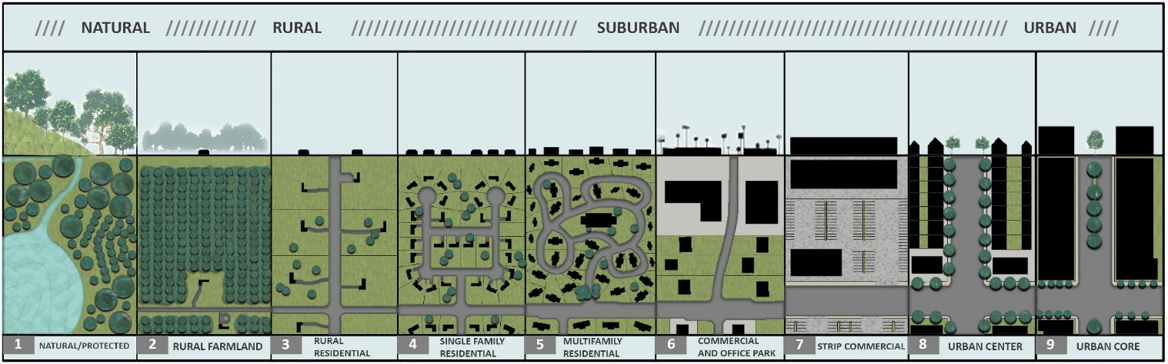
Figure credit: DPZ & Co. (Adapted the Urban and Sprawl transects for Land Use Scenario Assessments)
C |  | Future Shift of Regional Population Growth  Compare the population growth anticipated for the PDAs under each scenario to the growth projections for the FLUSA analyzed in Part B, Step 3. This comparison can be qualitative based on interviews with local planners. Changes in the character or density of the residential development that could affect stormwater runoff or community connections, i.e. development density, design requirements, multi-modal plans, should be specifically noted.  Example: Projections for population growth for the FLUSA are projected to be relatively low with an annualized growth rate of 1.0 percent. Local planners have indicated there are some lower density residential projects proposed within some of the PDAs, regardless of the project scenario. Under the No Build scenario, population growth projections would be similar to FLUSA projections. The Build scenario would help improve travel and access to more developable land, so population growth is anticipated to be greater in a majority of the PDAs compared to the projections for the FLUSA.
D |  | Future Shift of Regional Employment Growth  Compare the employment growth anticipated for the PDAs under each scenario to the growth projections for the FLUSA analyzed in Part B, Step 4. This comparison can be qualitative based on interviews with local planners. Changes in the character or density of the commercial, industrial, or institutional development that could affect stormwater runoff or community connections, i.e. development density, design requirements, multi-modal plans, should be specifically noted.  Example: Projections for employment growth for the FLUSA are projected to be relatively low with an annualized growth rate of 0.8 percent. Local planners have indicated that employment growth within the PDAs would be similar to the projections for the FLUSA. The Build scenario is expected to induce commercial development at new intersections; therefore employment growth is expected to be greater than projections for the FLUSA within some of the PDAs.
E |  | Pressure for Land Development Outside Regulated Areas  Discuss if development is expected to increase outside of regulated areas due to either scenario. The focus of this section shall be on natural system regulations including but not limited to stream buffers, watershed areas, floodway areas, habitat areas, and stormwater regulations.  Example: Most of the PDAs are subject to a combination of regulations which include the Neuse River Buffer Rules, a Watershed Protection Ordinance, a Flood Damage Protection Ordinance, CAMA permits, NCNHP Managed Areas for Conservation, NCDOT On-Site Mitigation Sites, and the Neuse River Basinwide Water Quality Plan. The existing regulations would limit development outside of regulated areas.
F |  | Planned/Managed Land Use and Impacts  Report if development is more likely to occur in areas without coordinated land use and stormwater management plans due to either scenario. The baseline for this analysis should be the land use authority’s current land use and stormwater management regulations. Assess how restrictive the current land use and stormwater management plans are. For example, a local zoning ordinance that does not protect stream buffers would be less restrictive.  Example: There are existing land use and stormwater management plans in place for the majority of the PDAs. The plans are restrictive in that stream buffers are established precluding development. Growth management provisions such as an urban growth boundary are not in place. Under the No-Build scenario development is expected to occur in areas where these plans are in place. However, under the Build scenario some residential development is expected in areas where the local stormwater management plan does not apply.

2 | Land Use Scenario Assessment Matrix
Complete the Land Use Scenario Assessment Matrix for the Build and No-Build scenarios based on the findings from Part E, Step 1 above by placing “Build Scenario” and “No-Build Scenario” in the appropriate cells based on the level of concern for each of the six categories. The five levels of concern to choose from are: high, medium-high, medium, medium-low, and low. Note that divergence between the levels of concern for the Build and No-Build scenarios indicate a greater likelihood for indirect land use impacts.

A separate Land Use Scenario Assessment Matrix should be completed for each project alternative, or grouping of similar project alternatives. A separate matrix is not completed for each PDA. Guidance for completing each category of the matrix is provided below.

A |  | .
   | Scope of Development
  Ranking | Ranking Measure
  High | 40 percentage point or greater increase in developed land within the PDAs
  Medium-High | 30 - 39 percentage point increase in developed land within the PDAs
  Medium | 20 - 29 percentage point increase in developed land within the PDAs
  Medium-Low | 10 - 19 percentage point increase in developed land within the PDAs
  Low | 0 - 9 percentage point increase in developed land within the PDAs
B
   | Development Intensity
  Ranking | Ranking Measure
  High | Higher development intensities are existing, planned, or anticipated within a majority of the PDAs  Development Intensity Types (see figure): 6, 7, 8, 9
  Medium-High | Higher development intensities are existing, planned, or anticipated within some of the PDAs  Development Intensity Types (see figure): 6, 7, 8, 9
  Medium | Medium development intensities are existing, planned, or anticipated within some of the PDAs  Development Intensity Types (see figure): 5
  Medium-Low | Lower development intensities are existing, planned, or anticipated within some of the PDAs  Development Intensity Types (see figure): 3, 4
  Low | There is no development existing, planned, or anticipated within any of the PDAs  Development Intensity Types (see figure): 1, 2
  Note: Refer to the Development Transect below to identify development intensities. Each development intensity type is labeled underneath the figure (e.g. 1).
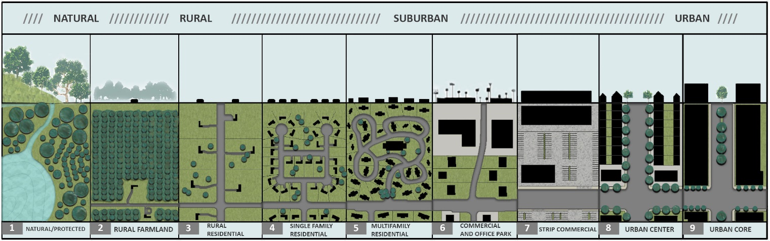
Figure credit: DPZ & Co. (Adapted the Urban and Sprawl transects for Land Use Scenario Assessments)

C |  | .
   | Future Shift of Regional Population Growth
  Ranking | Ranking Measure
  High | Population growth is anticipated in the majority of the PDAs and is expected to be greater than growth projections for the FLUSA
  Medium-High | Population growth is anticipated in some of the PDAs and is expected to be greater than growth projections for the FLUSA
  Medium | Population growth is anticipated in the majority of the PDAs and is expected to be similar to growth projections for the FLUSA
  Medium-Low | Population growth is anticipated in the majority of the PDAs is expected to be less than growth projections for the FLUSA
  Low | Population growth is not anticipated within any of the PDAs based on interviews with local planners
D |  | .
   | Future Shift of Regional Employment Growth
  Ranking | Ranking Measure
  High | Employment growth is anticipated in the majority of the PDAs and is expected to be greater than growth projections for the FLUSA
  Medium-High | Employment growth is anticipated in some of the PDAs and is expected to be greater than growth projections for the FLUSA
  Medium | Employment growth is anticipated in the majority of the PDAs and is expected to be similar to growth projections for the FLUSA
  Medium-Low | Employment growth is anticipated in the majority of the PDAs is expected to be less than growth projections for the FLUSA
  Low | Employment growth is not anticipated within any of the PDAs based on interviews with local planners
E |  | .
   | Pressure for Land Development Outside Regulated Areas
  Ranking | Ranking Measure
  High | All acres in the PDAs are outside a regulated area
  Medium-High | The majority of acres in the PDAs are outside a regulated area
  Medium | Approximately half of the acres in the PDAs are outside a regulated area
  Medium-Low | The majority of acres in the PDAs are inside a regulated area
  Low | All acres in the PDAs are inside a regulated area
F
   | Planned/Managed Land Use and Impacts
  Ranking | Ranking Measure
  High | Land development and stormwater management goals are non-existent for PDAs where development is likely to occur (e.g. no land use plan or riparian buffer rule)
  Medium-High | Some land development and stormwater management goals in place while others are non-existent for PDAs where development is likely to occur (e.g. land use plan, no riparian buffer rule)
  Medium | Land development and stormwater management goals are in place but are not restrictive for PDAs where development is likely to occur (e.g. zoning ordinance in place but does not include stream buffers)
  Medium-Low | Land development and stormwater management goals are in place and are restrictive for PDAs where development is likely to occur (e.g. zoning ordinance prohibits development in stream buffers)
  Low | Restrictive land development and stormwater management goals are in place for PDAs where development is likely to occur such as a state riparian buffer rule. Growth management provisions such as an urban growth boundary are also in place.

3 | Prepare a Land Use Scenario Assessment Matrix Summary Statement
A |  | Prepare a summary that states the result of the Land Use Scenario Assessment Matrix and the key reasons for the result. The summary should note which Matrix category rankings are similar for the No-Build and Build scenarios and which rankings are different for the scenarios. An example summary statement is provided below:  The Land Use Scenario Assessment Matrix resulted in “Indirect Land Use Effects Possible.” It showed that when compared to the No-Build Scenario, the Build Scenario would likely result in increased development and more intense development. While the overall growth projections for the FLUSA are relatively low, the construction of a new facility would likely increase the pressure/demand for new commercial/industrial development. The No-Build and Build scenarios were ranked similarly for the pressure for land development outside regulated areas and planned area categories given that the project is within the municipal limits.

PART  F | Indirect and Cumulative Effects Assessment
Determine whether an Indirect and Cumulative Effects Assessment should be completed based on the environmental document type and result of the LUSA Matrix:

Environmental Document Type | Indirect and Cumulative Effects Assessment
Environmental Impact Statement (EIS) | Complete the Indirect and Cumulative Effects Assessment
Environmental Assessment (EA) | Complete the Indirect and Cumulative Effects Assessment only if the LUSA Matrix results in one of the following statements shown in the “Result” column:  - Indirect Land Use Effects Anticipated  - Indirect Land Use Impacts Likely  - Indirect Land Use Effects Possible  Refer to Appendix A for an example.
.

1 |  | Summarize Past, Present, and Future Projects in the FLUSA
A |  |  |  | First, determine whether the Indirect and Cumulative Effects Assessment is required based on the criteria above. If it is required, summarize the past, current, and future transportation and infrastructure projects within the FLUSA in the tables provided in the LUSA Report Template. Examples are shown below in italics.  Past Projects  Current Projects  Future Projects
  Project | Description of Action
  Northern Bypass | A full-control of access highway was constructed as a bypass around the northern part of the Town
  Project | Description of Action
  Main St. Complete Streets Project | As part of a complete streets project, Main St. is currently being widened from two lanes to two lanes with a center turn lane and bicycle lanes in each direction.
  Project | Description of Action
  Southern Bypass | An extension is proposed to connect the existing bypass with Highway 1 to the south.
2 | Cumulative Effects Analysis
A |  |  | Summarize the indirect and cumulative effects of past actions, current activities, and future development on notable water quality, natural habitat, and community features by completing the tables as shown below.  Include the foreseeable impacts of this project under the Future Development column. As shown under Notable Community Features, cumulative effects resulting from the project may be positive such as improved bicycle and pedestrian access. Examples are shown below in italics.
A |  |  | Notable Water Quality Features  Notable Natural Habitat Features  Notable Community Features  .
  Feature | Past Actions | Current Activities | Future Development
  Nutrient Sensitive Water (NSW)  Example: Jordan Lake Rules | Construction of the Northern Bypass led to increased runoff | Best Management Practices included in the Main St. complete streets project are likely to minimize impacts to water quality | Increased impervious surface from this project and proposed development in proximity to NSW may increase runoff and sedimentation
  Feature | Past Actions | Current Activities | Future Development
  Natural Heritage Program (NHP) Natural Area Example: Arnett Branch Long Leaf Pine Forest | Rural residential development and farming activities encroached on the Natural Area | Shopping center under construction on open space adjacent to the Natural Area may reduce habitat and increase air, noise, and water pollution | This project would increase property access, which may induce further development in the vicinity of the Natural Area
  Feature | Past Actions | Current Activities | Future Development
  Community Center | Construction of a full-control of access highway limited bicycle and pedestrian access to the Community Center | Recently formed neighborhood group has increased programming and use of the Community Center | This project may improve bicycle and pedestrian access to Community Center by providing sidewalks and bicycle lanes

3 | Complete the Cumulative Effects Matrices for the Natural and Human Environment
A |  | Complete the Cumulative Effects Matrix – Natural Environment and the Cumulative Effects Matrix – Human Environment.  Rank the cumulative effects to notable natural and human environment features according to past actions, current activities, and future development. The five levels of concern to choose from are: high, medium-high, medium, medium-low, and low. Examples of cumulative effects for each of these five levels of concern are provided below.
  Notable Water Quality Features
  Ranking | Ranking Measure | Example
  High | A water quality feature(s) would receive a high ranking when it is not explicitly protected by policies/regulations AND experienced or is anticipated to experience severe impact(s) in the past, present, or future. | With no regulations to clearly prevent the action, a roadway widening project affected runoff channels adjacent to an intensive farming operation. This resulted in both sedimentation and pesticide and fertilizer contamination of nearby waters during construction.
  Medium-High | A water quality feature(s) would receive a medium-high ranking when it is not explicitly protected by policies/regulations AND experienced or is anticipated to experience high impact(s) in the past, present, or future. | A new shopping mall has large impervious surfaces in a municipality without stormwater ordinances, thereby resulting in contamination of a nearby wetland and stream.
  Medium | A water quality feature(s) would receive a medium ranking when it is not explicitly protected by policies/regulations AND experienced or is anticipated to experience moderate impact(s) in the past, present, or future. | The redevelopment of a downtown plaza may result in future contamination of a stream due to lawn treatments; no local ordinance mitigates this action.
  Medium-Low | A water quality feature(s) would receive a medium-low ranking when it is protected by policies/regulations AND experienced or is anticipated to experience low impact(s) in the past, present, or future. | Municipal ordinances require the installation of rain gardens for a future commercial development thereby minimizing the impacts to an adjacent stream.
  Low | A water quality feature(s) would receive a low ranking when it is protected by policies/regulations AND experienced or is anticipated to experience no impact(s) in the past, present, or future. | Zoning ordinances that prohibit development in stream buffers effectively avoided contamination from a proposed residential development.
B
  Notable Natural Habitat Features
  Ranking | Ranking Measure | Example
  High | Natural habitat feature(s) would receive a high ranking when it is not explicitly protected by policies/regulations AND experienced or is anticipated to experience severe impact(s) in the past, present, or future. | The damming of a river to create a reservoir has severely impacted the aquatic and terrestrial habitats of the region downstream even though it was in compliance with applicable state and federal regulations and permits.
  Medium-High | Natural habitat feature(s) would receive a medium-high ranking when it is not explicitly protected by policies/regulations AND experienced or is anticipated to experience high impact(s) in the past, present, or future. | A new suburban development will encroach on a natural habitat feature. Requirements for buffers surrounding the feature are not present in the local zoning ordinances, thereby reducing the ability to mitigate or prevent the impacts of this action.
  Medium | Natural habitat feature(s) would receive a medium ranking when it is not explicitly protected by policies/regulations AND experienced or is anticipated to experience moderate impact(s) in the past, present, or future. | Limited protections exist to mitigate light pollution from a highway that causes disturbance to the surrounding animal species.
  Medium-Low | Natural habitat feature(s) would receive a medium-low ranking when it is protected by policies/regulations AND experienced or is anticipated to experience low impact(s) in the past, present, or future. | Local zoning ordinances have required restoration and mitigation measures, such as the replanting of native vegetation, following commercial development.
  Low | Natural habitat feature(s) would receive a low ranking when it is protected by policies/regulations AND experienced or is anticipated to experience no impact(s) in the past, present, or future. | The Natural Area within the FLUSA of a proposed roadway project is designated as a Dedicated Nature Preserve. State regulations establish a lasting conservation commitment, thereby avoiding impacts to natural habitats within the Natural Area.
C
  Notable Community Features
  Ranking | Ranking Measure | Example
  High | Community feature(s) would receive a high ranking when it is not explicitly protected by policies/regulations AND experienced or is anticipated to experience severe impact(s) in the past, present, or future. | An urban roadway connector project would impact a vacant lot used by the community as a community garden that provides fresh produce to an underserved neighborhood. Since the lot is privately owned and is used voluntarily, no protections exist to prevent this impact.
  Medium-High | Community feature(s) would receive a medium-high ranking when it is not explicitly protected by policies/regulations AND experienced or is anticipated to experience high impact(s) in the past, present, or future. | Construction of a full-control of access highway severed pedestrian and bicycle access to the community center for the neighborhood located on the other side of the highway.
  Medium | Community feature(s) would receive a medium ranking when it is not explicitly protected by policies/regulations AND experienced or is anticipated to experience moderate impact(s) in the past, present, or future. | A roadway project changed local traffic patterns, thereby increasing traffic and noise in front of an elementary school. No policies or regulations are in place to address these specific impacts.
  Medium-Low | Community feature(s) would receive a medium-low ranking when it is protected by some policies/regulations AND experienced or is anticipated to experience low impact(s) in the past, present, or future. | Land use designations may preserve the economic vitality of a commercial district after construction of a roadway.
  Low | Community feature(s) would receive a low ranking when it is protected by policies/regulations AND experienced or is anticipated to experience no impact(s) in the past, present, or future. | A community park is located adjacent to a complete street project, and bicycle, pedestrian and landscape treatments are proposed that would effectively maintain the park’s character.

4 | Provide Cumulative Effects Summary Statements
A |  | Provide two cumulative effects summary statements based on the results of the Cumulative Effects Matrix – Natural Environment and the Cumulative Effects Matrix – Human Environment. The statements should include the results from the matrices following this example provided below:  The matrices resulted in “Cumulative Effects Expected” for the natural environment and “Possible Cumulative Effects” for the human environment.  The statements should explain the reasons for the results by referring to the matrix categories. An example focusing on one matrix category is provided below:  The “Cumulative Effects Expected” result for water quality features was due in part to a high ranking for Notable Water Quality Features – Past Actions given the history of point source contamination as well as runoff from nearby development activity.
5 | Prepare Water Quality Statement
A |  |  | Modify the standard water quality effects and natural environmental impact language included in Appendix C: Standard Language to fit the project. The statement should include a summary of the major water quality impacts that could result from the project such as change in land use and increase in impervious surfaces. Note whether there are adopted local or state ordinances and regulations in place that may mitigate potential water quality impacts or if the absence of ordinances and regulations may exacerbate potential impacts. Refer to the example provided below:  Qualitative analyses of the probable development patterns in the FLUSA suggest that changes in land use resulting from the project and subsequent private and public development actions are not likely to notably increase impervious surface over the No‐Build scenario. There are adopted ordinances and regulations to mitigate potential water quality effects due to increased impervious surfaces and water runoff. All municipalities within the FLUSA have stormwater ordinances that establish density and intensity standards for development, which would minimize impacts resulting from the planned extensions of water service and planned developments in the FLUSA.  The potential for the degradation of water quality also exists through erosion and stream sedimentation. Any direct natural environmental impacts by NCDOT projects would be addressed by avoidance, minimization, and mitigation consistent with programmatic agreements with the natural resource agencies during the Merger and Permitting processes.

APPENDICES
Appendix A: Matrix Examples
Appendix B: Mapping Guidance
Appendix C: Standard Language

Appendix A: Matrix Examples
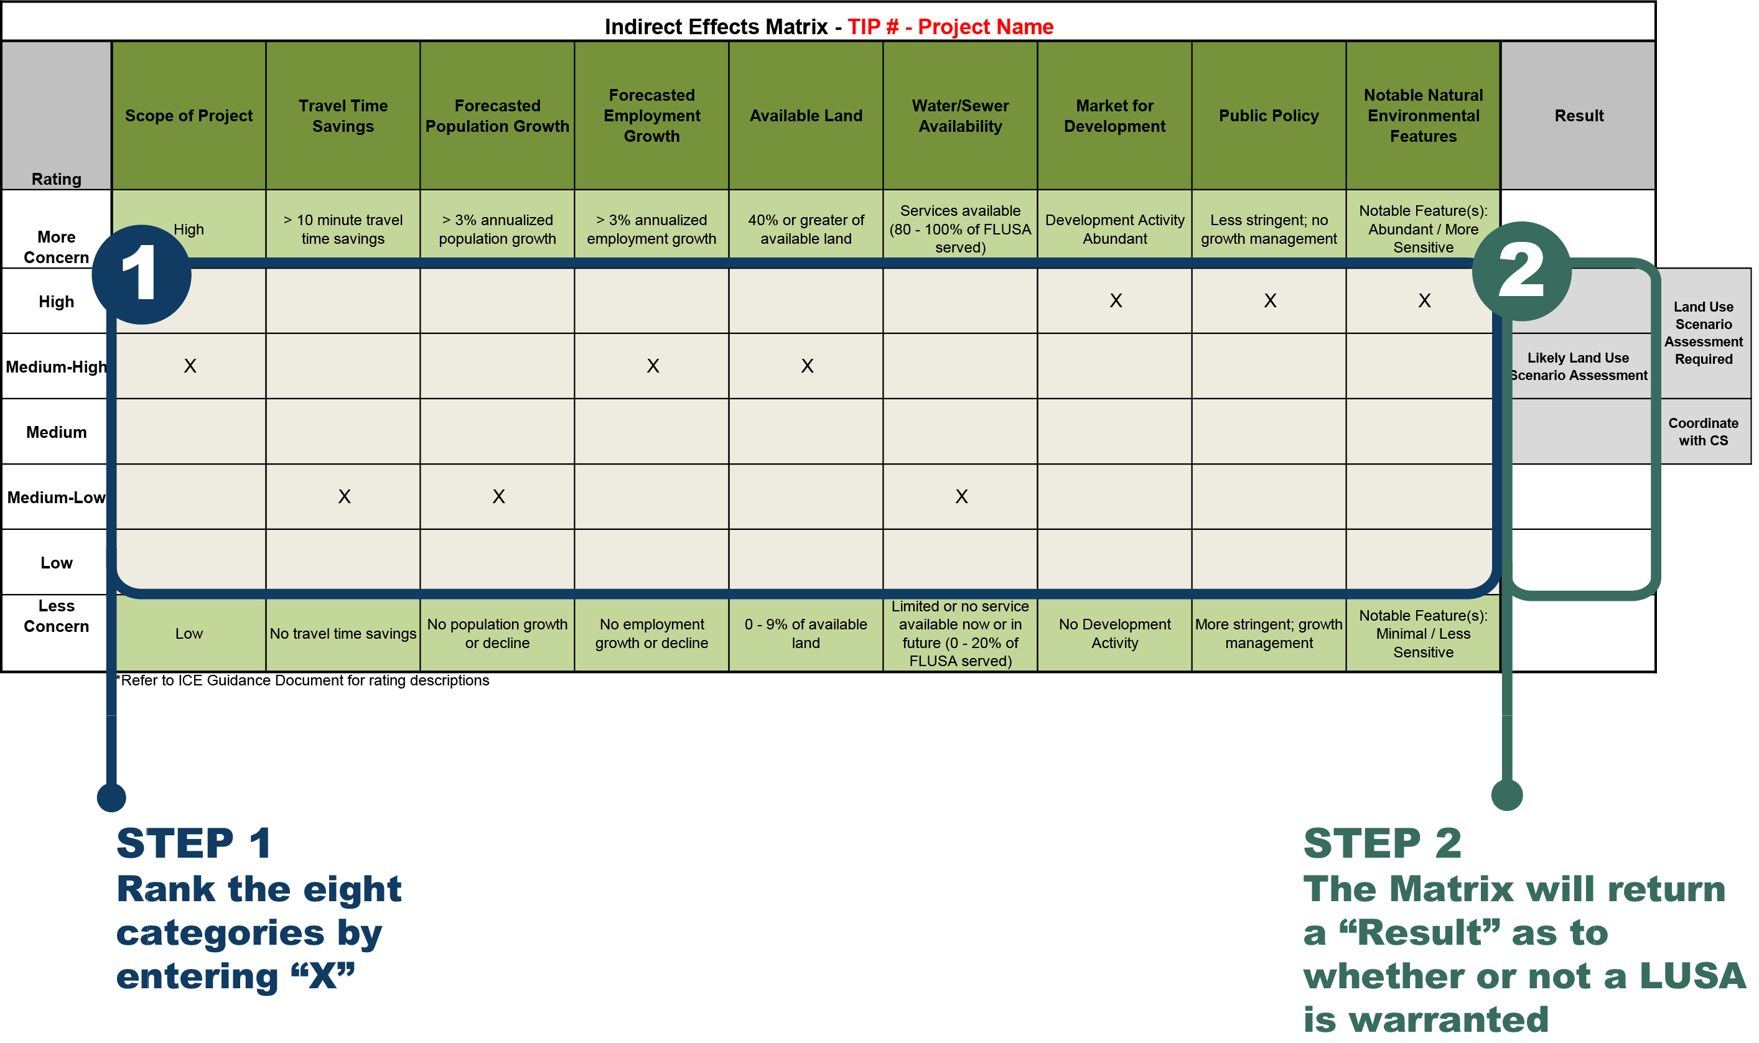
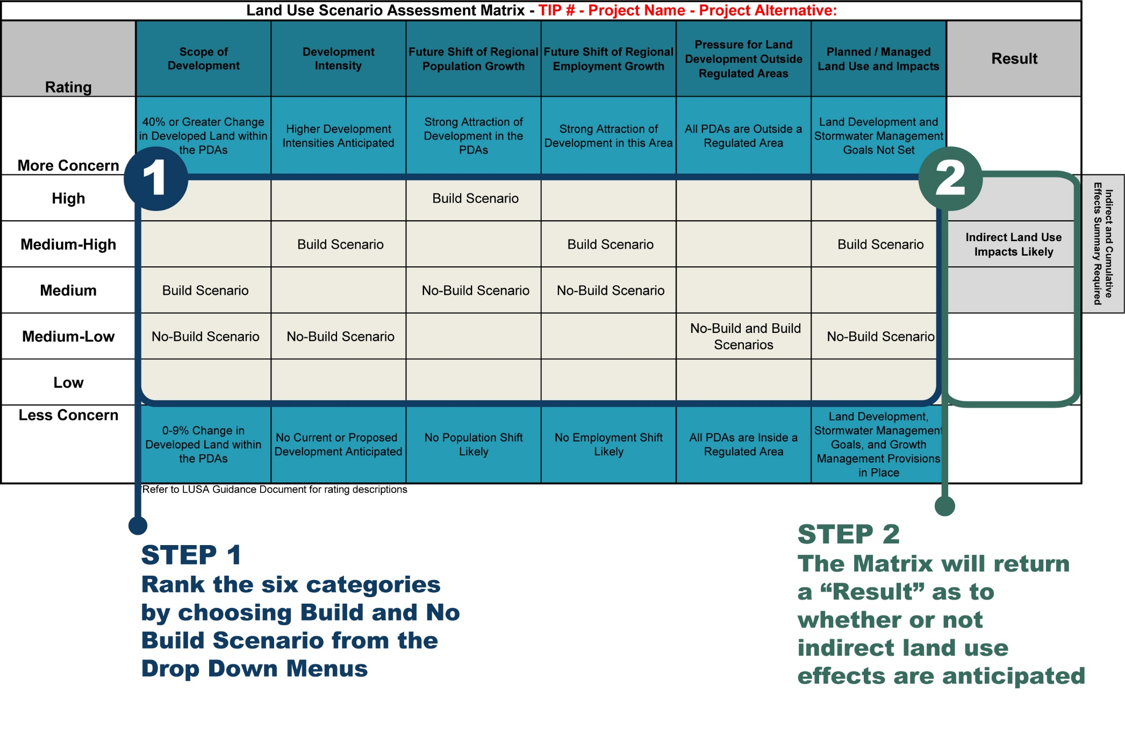
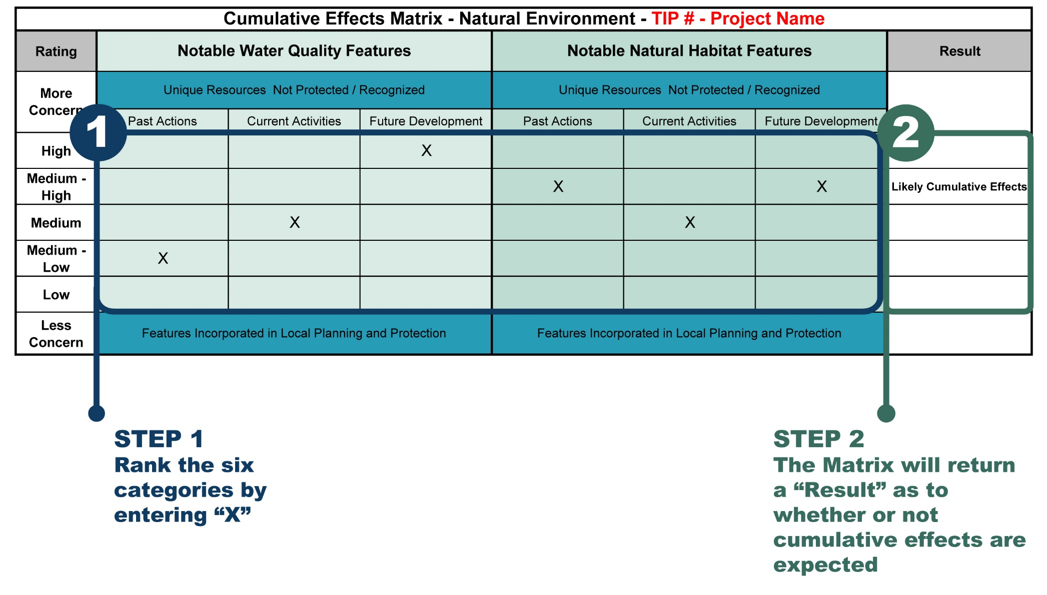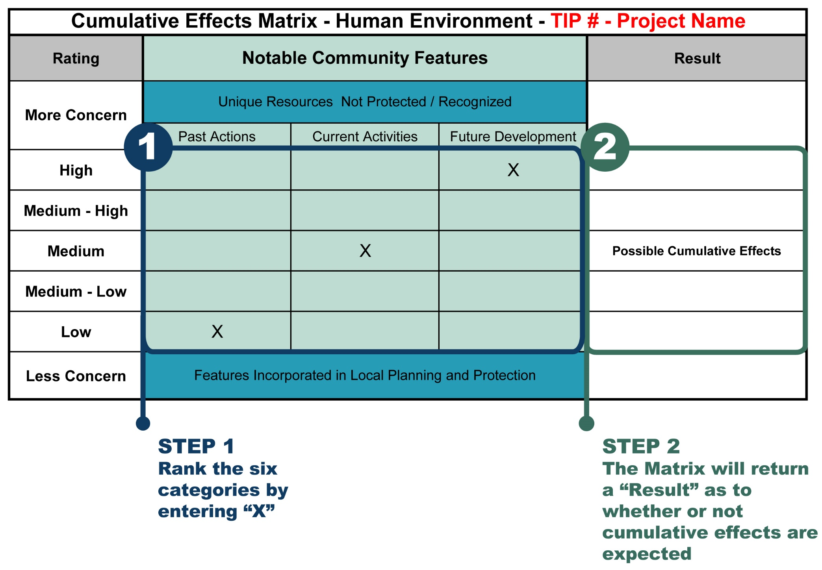

Appendix B: Mapping Guidance
Future Land Use Study Area Map
The map should contain the following layers and they should be displayed in this order:
- The STIP project being studied. Show individual alternatives/corridors if applicable.
- FLUSA Boundary in a solid, colored line (not black).
- All Roads. Use Highway Shield symbols with embedded route numbers as the label for Interstates, US and NC routes, and the local names (not SR numbers) of other state maintained secondary roads and local roads.
- Points indicating the location of major land use and traffic nodes (interchanges, dense commercial development centers).
- Hydrologic features, with labels.
- Any other property managed for conservation, preservation or recreational purposes (shaded or patterned polygon).
- State, county, municipal boundaries (outline states and counties, shade municipal polygons). Label municipalities on the map.
- Include a title, legend, scale bar, and north arrow.
- Provide the data sources of the GIS layers on the map.
Project Area Transportation Projects
The map should contain the following layers and they should be displayed in this order:
- STIP Points and Roads. Display and label with STIP number all of the projects that appear in the map context.
- FLUSA Boundary in a solid, colored line (not black).
- All Roads. Use Highway Shield symbols with embedded route numbers as the label for Interstates, US and NC routes, and the local names (not SR numbers) of other state maintained secondary roads and local roads.
- Hydrologic features.
- State, county, municipal boundaries (outline states and counties, shade municipal polygons).
- Include a title, legend, scale bar, and north arrow.
- Provide the data sources of the GIS layers on the map.
Notable Human Environmental Features Map
The map should contain the following layers and they should be displayed in this order:
- FLUSA Boundary in a solid, colored line (not black).
- Notable Human Environmental Features: bike routes, hurricane evacuation routes, strategic transportation corridors, cemeteries, community centers, active farmland, Voluntary Agricultural Districts (VADs), hospitals, fire stations, libraries, police and EMS stations, places of worship, and schools.
- All Roads. Use Highway Shield symbols with embedded route numbers as the label for Interstates, US and NC routes, and the local names (not SR numbers) of other state maintained secondary roads and local roads.
- Hydrologic features.
- State, county, municipal boundaries (outline states and counties, shade municipal polygons).
- Include a title, legend, scale bar, and north arrow.
- Provide the data sources of the GIS layers on the map.
Notable Natural Environmental Features Map
The map should contain the following layers and they should be displayed in this order:
- FLUSA Boundary in a solid, colored line (not black).
- Notable Natural Environmental Features: habitat areas, Natural Heritage Program Natural Areas, major waterways, wetlands, water supply watershed areas, waters under jurisdiction of a NC Basinwide Management Plan, 303(d) listed streams, trout streams, Outstanding Resource Waters, NC Natural & Scenic Rivers, and US Wild & Scenic Rivers.
- HUC boundaries, if they were used to define the FLUSA.
- All Roads. Use Highway Shield symbols with embedded route numbers as the label for Interstates, US and NC routes, and the local names (not SR numbers) of other state maintained secondary roads and local roads.
- State, county, municipal boundaries (outline states and counties, shade municipal polygons).
- Include a title, legend, scale bar, and north arrow.
- Provide the data sources of the GIS layers on the map.
Water and Sewer Availability Map
The map should contain the following layers and they should be displayed in this order:
- FLUSA Boundary in a solid, colored line (not black).
- Existing and Future Water Treatment and Wastewater Treatment Plants.
- Existing and Future Water Distribution Service Areas and Sewer Service Areas.
- All Roads. Use Highway Shield symbols with embedded route numbers as the label for Interstates, US and NC routes, and the local names (not SR numbers) of other state maintained secondary roads and local roads.
- Hydrologic features.
- State, county, municipal boundaries (outline states and counties, shade municipal polygons).
- Include a title, legend, scale bar, and north arrow.
- Provide the data sources of the GIS layers on the map.
Available Land Map
The map should contain the following layers and they should be displayed in this order:
- FLUSA Boundary in a solid, colored line (not black).
- Parcel outlines (if available).
- Land Available for Development (undeveloped (vacant) and underutilized)
- Developed Land
- All Roads. Use Highway Shield symbols with embedded route numbers as the label for Interstates, US and NC routes, and the local names (not SR numbers) of other state maintained secondary roads and local roads.
- Hydrologic features including wetlands.
- State, county, municipal boundaries (outline states and counties, shade municipal polygons).
- Include a title, legend, scale bar, and north arrow.
- Provide the data sources of the GIS layers on the map.
Probable Development Areas Map
The map should contain the following layers and they should be displayed in this order:
- FLUSA Boundary in a solid, colored line (not black).
- Depending on the scale of the map, consider including parcel lines.
- Probable Development Area boundaries.
- Notable natural and human environmental features.
- All Roads: use Highway Shield symbols with embedded route numbers as the label for Interstates, US and NC routes, and the local names (not SR numbers) of other state maintained secondary roads and local roads
- Hydrologic features including wetlands.
- Existing land uses and/or zoning (if available).
- State, county, municipal boundaries (outline states and counties, shade municipal polygons).
- Title, date, legend, scale bar, and north arrow.
- Data sources of the GIS layers on the map.

GIS Data Sources
GIS data may be obtained from the municipal or county planning or GIS department where the project is located. Statewide data is available from NCDOT through its Enterprise GIS website and from NC One Map: https://connect.ncdot.gov/resources/gis/Pages/default.aspx
http://www.nconemap.net/

Appendix C: Standard Language

Standard Water Quality Language
The potential for the degradation of water quality also exists through erosion and stream sedimentation. Any direct natural environmental impacts by NCDOT projects would be addressed by avoidance, minimization, and mitigation consistent with programmatic agreements with the natural resource agencies during the Merger and Permitting processes.
Standard Natural Environmental Impact Language
Direct natural environmental impacts by NCDOT projects would be addressed by avoidance, minimization, or mitigation, consistent with programmatic agreements with the natural resource agencies during the Merger and Permitting processes.

